Python (Programming Language)
Python (Programming Language)

3.
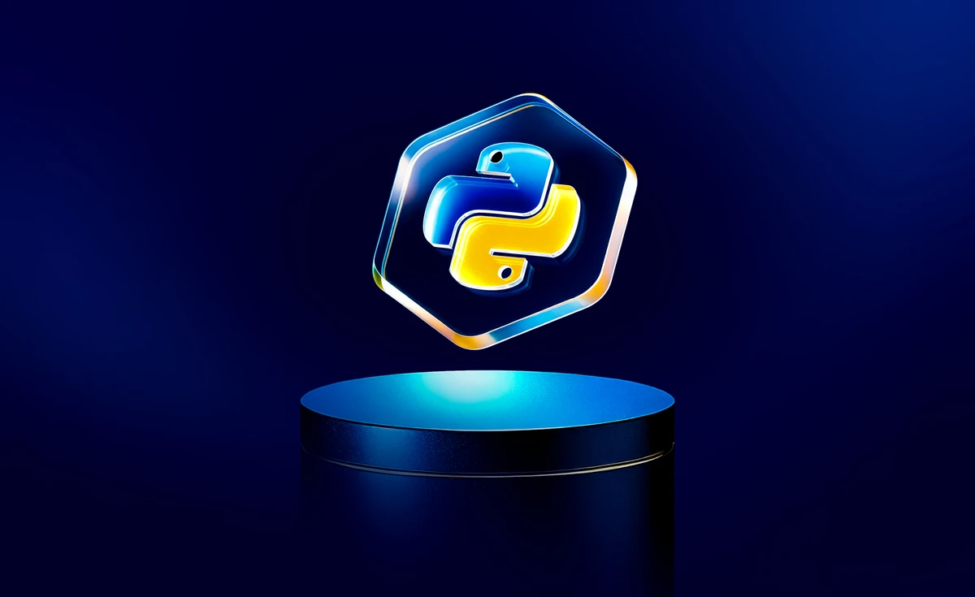
- What is a programming language ?
A programming language is a set of instructions, rules, and syntax that allows humans to communicate with computers and create software.

Example of Programming Language :
- Python
- Java
- C / C++
- JavaScript
- R
- SQL
- PHP
- Kotlin / Swift

- Why do we need a programming language ?
We use programming languages to communicate with computers and make them perform tasks. A computer cannot understand human language — it only understands binary (0s and 1s).
Programming languages act as a bridge between humans and machines.

- What is software ?
Software is a set of instructions, data, or programs that tell a computer or electronic device how to operate and perform specific tasks.
It is the non-physical (intangible) part of a computer system.
Or
Software is a collection of programs that enables a computer to work and perform useful tasks.

- Programs
A program is a set of instructions written in a programming language that tells a computer what to do step-by-step.

Types of Software perspective of development

- System Software : Ex : Windows,Linux, ios, MacOS etc..
- Application Software : Ex : Excel, Power Point, Zoom etc..
- Web Application Software : Ex : Gmail, Twitter, Facebook etc..
- Device Application software : Ex : Gaming & App
- AI / IOT (Internet of Things) : Data Science & Data Analytics , Alexa etc..

Python exists in all fields and types of software except system software.

- What is Python ?

Python is a high-level, general-purpose programming language used to build many kinds of applications like websites, data analysis, AI, automation, and more.

Or

Python is a high-level, interpreted, object-oriented, and open-source programming language.

Key Features of Python
- Easy to read and write
- Simple syntax (like English)
- Works on all operating systems
- Huge library support
- Used in many fields (web, AI, data, automation, etc.)

History of Python (Short Notes)
- Python was created by Guido van Rossum in the late 1980s.
- Development started in 1989 at the National Research Institute (CWI) in the Netherlands.
- First official version Python 0.9.0 was released in 1991.
- Python included features like functions, exception handling, and core data types in early versions.
- Python 1.0 was released in 1994 with new features like modules and functional programming tools.
- Python 2.0 came in 2000, adding garbage collection and Unicode support.
- Python 3.0 was released in 2008 with major improvements and better design (not backward compatible with Python 2).

- What Python Is Used For
- Data Science and Machine Learning
  - It is a leading language in AI/ML due to powerful libraries like TensorFlow, Keras, NumPy, and pandas
- Data Analytics
  - For Data Analytics we are using Numpy, Pandas Matplotlib & seaborn
- Artificial Intelligence
- Web Development
  - Used for back-end (server-side) web development using frameworks such as Django and Flask.
- IoT
- Automation
  - Often used to write scripts to automate repetitive tasks, such as file management or web scraping.
- Software development
- Cybersecurity

Python syntax
print(“Hello World!”)

- Character set in Python
A character set is a set of valid characters acceptable by a programming language in scripting.
- Alphabets: All capital (A-Z) and small (a-z) alphabets.
- Digits: All digits 0 - 9
- Special Symbols: Python supports all kind of special symbols like,
“ ‘ ; : ! ~ @ # $ % ^ ( ) _ + - = { } [ ] \ .
- White Spaces: White shapes like tab space, blank space, new line.
- Other : All ASCII and UNICODE characters are supported by python that constitutes the python character set.
- Tokens in Python
Tokens are the smallest building blocks of a Python program, such as keywords, identifiers, literals, operators, and punctuation.
Or
A token is the smallest individual unit in a python program. All statements and instructions in a program are built with tokens. The various tokens in python are:
- Keywords.
- Identifiers (Variable)
- Literals (values)
- Operators
- Punctuators

- Keywords : Keywords are special reserved words in Python that have a fixed meaning and cannot be used as variable or function names
(e.g., if, else, while, for, class, True).

- Identifiers (Variable) : Identifiers are names given to variables, functions, classes, and objects in a Python program.
Example: name, total_sum, student1.

- Literals (Values) : Literals are fixed values used in a program, such as numbers, strings, or Boolean values.
Examples: 10, "Hello", 3.14, True.

- Operators : Operators are symbols that tell the computer what action to perform on values.

- Punctuators : Punctuators are special symbols that help Python understand the structure of a program.
Ex : [] , {} () , ; : “ ‘ / # etc..
- Comments : Comments are lines in a program that Python does not execute.
There are two types of Comments
- Single line Comments : Denoted by #
- Multi-line comments : Written using triple quotes “”” “””

- Variable : A variable in Python is a name used to store a value.
It works like a container that holds data.
Example:
x = 10 # x is a variable storing value 10
name = "Prince"

Limitations of Variables
Variables also have some rules and limits:

1. Variable names cannot start with a number
❌ 1name = "abc"
✔️ name1 = "abc"

2. Cannot use special characters except _
❌ my-name
✔️ my_name

3. Cannot use Python keywords as variable names
❌ for = 10
✔️ count = 10

4. Variable names are case-sensitive
Age and age are different.

5. Variable value is stored in memory, so too many variables use memory
More variables = more memory used.

